 | SEMINAR REPORT | 

A Seminar Report on
Smart Inventory Management System using IoT and AI/ML
Submitted in partial fulfilment for the award of
THIRD YEAR DIPLOMA IN
COMPUTER ENGINEERING
By
Sr. No | Enrollment Number | Seat Number | Name of Student
1 | 24610960269 | 388570 | Shaikh Mohammad Zakariya Haffizuddin
2 | 24610960270 | 388571 | Shaikh Suher Rayaz
3 | 24610960271 | 388572 | Sharma Nilesh Ashok
4 | 24610960300 | 388599 | Ansari Zeeshan Habib

Under the Guidance of
Prof. N. D. Patel
FOR THE ACADEMIC YEAR: 2026 – 2027
DEPARTMENT OF COMPUTER ENGINEERING
S.S.V.P. S’s Bapusaheb Shivajirao Deore Polytechnic, Dhule
(Institute Code: 0059)

S.S.V.P. S’s Bapusaheb Shivajirao Deore Polytechnic, Dhule
(An Affiliated Institute of Maharashtra State Board of Technical Education)
DEPARTMENT OF COMPUTER ENGINEERING
CERTIFICATE
This is to certify that the following students
Sr. No | Enrollment Number | Seat Number | Name of Student
1 | 24610960269 | 388570 | Shaikh Mohammad Zakariya Haffizuddin
2 | 24610960270 | 388571 | Shaikh Suher Rayaz
3 | 24610960271 | 388572 | Sharma Nilesh Ashok
4 | 24610960300 | 388599 | Ansari Zeeshan Habib

of CO5K Semester of Diploma in Computer Engineering of S.S.V.P. S’s B. S. Deore Polytechnic, Dhule (Inst. Code: 0059) have completed the term work satisfactorily in the Course Seminar Presentation and Project Initiation (Course Code: 315003) on the topic “Smart Inventory Management System using IoT and AI/ML” for the academic year 2026 to 2027 as prescribed in the curriculum.
Place: Dhule
Date : 17/10/2026
Signature: | Signature:
Name : Prof. N. D. Patel | Name : Prof. N. D. Patel
Subject Teacher | Head of the Department
Seal of
Institution

TABLE OF CONTENTS
Sr. No. | Chapter | Page No.
 | Abstract | i
 | List of Figures | ii
 | List of Tables | iii
1 | Introduction | 1
2 | Literature Review | 3
3 | Information | 9
4 | Advantages and Disadvantages | 14
5 | Conclusion | 15
6 | Project Initiation: | 16
 | 6.1) Description of Problem Statement | 16
 | 6.2) Scope and Objectives | 16
 | 6.3) Stakeholders | 17
 | 6.4) Platform / Equipment / Resources Identification | 17
7 | Seminar Presentation | 19
 | Bibliography | 29
 | References | 30

ABSTRACT
Inventory management in most organizations, from large warehouses to small shops and college laboratories, still depends on manual stock registers, periodic physical counting and guesswork while placing orders. This leads to stock-outs, over-stocking, wastage of perishable goods, misplaced equipment, and financial loss. The Internet of Things (IoT) and Artificial Intelligence / Machine Learning (AI/ML) together offer a solution: IoT devices such as RFID readers, weight sensors and environmental sensors capture the stock position in real time, while ML models analyse past usage to forecast future demand and suggest when and how much to reorder.
This seminar report reviews eleven research papers on IoT- and AI/ML-based inventory management, arranged from large-scale supply-chain and warehouse systems down to retail stores, small warehouses and a single laboratory. The reviewed work shows that RFID and sensor-based tracking improve stock accuracy, and that ensemble models such as Random Forest give reliable demand forecasts (for example, 93.75% accuracy with an IoT and Wireless Sensor Network system, and a MAPE of 3.41% for supply-chain demand prediction). Based on this survey, the report proposes a low-cost Smart Inventory Management System for a college department or small store, using an ESP32 microcontroller, RFID and load-cell sensors, a Python Flask backend with a MySQL database, a Random Forest demand forecasting model and a web dashboard with automatic low-stock alerts.
Keywords: Inventory Management, Internet of Things (IoT), Machine Learning, RFID, Demand Forecasting, ESP32, Random Forest.

LIST OF FIGURES
Fig. No. | Title | Page No.
3.1 | Working of Smart Inventory Management System | 10
3.2 | Architecture of Smart Inventory Management System | 12

LIST OF TABLES
Table No. | Title | Page No.
2.1 | Literature Review | 7
6.1 | Stakeholders | 17
6.2 | Equipment | 17
6.3 | Resources | 18
8.1 | Research Papers Referred | 31

CHAPTER 1

INTRODUCTION
The term “Internet of Things” (IoT) was coined by Kevin Ashton, a British technology pioneer, in 1999 during a presentation to the management of Procter & Gamble (P&G), where he was working in brand management. While handling a cosmetics product line, Ashton noticed that one popular shade of lipstick was regularly missing from store shelves, even though the company’s records showed that stock was available in its warehouses. He realised that the real problem was not a shortage of products but a lack of accurate, real-time information about where the products were.[13][14]
To solve this, Ashton proposed attaching small, low-cost Radio Frequency Identification (RFID) chips to products so that each item could be identified and tracked automatically over a network, without anyone counting it by hand. In the same year he co-founded the Auto-ID Center at the Massachusetts Institute of Technology (MIT) with Sanjay Sarma and David Brock, which researched how an electronic tag could be placed on every object so that it could be uniquely tracked in the most cost-effective way. His main goal was to let computers gather data about physical things on their own, using RFID and sensors, instead of depending on people to type it in, because human data entry is slow, limited and error-prone. If computers could count and track everything automatically, organizations would always know what is in stock and when it needs to be reordered, greatly reducing waste, loss and cost. This idea of automatic, real-time stock tracking is the foundation of the Smart Inventory Management System studied in this seminar. [12][13].
Inventory is the stock of raw materials, components, finished goods, consumables or equipment that an organization keeps in order to carry out its daily work. Whether it is a multinational warehouse, a supermarket, a hospital pharmacy or a college laboratory, every organization has to answer the same questions: what is in stock, where is it, how much will be needed, and when should it be reordered. Inventory management is the process of answering these questions accurately and at the lowest possible cost.
Traditional inventory management depends on manual entry in registers or spreadsheets and periodic physical counting. These methods are slow, prone to human error and give no real-time picture of stock. As a result, organizations face two opposite problems at the same time: understocking, which stops work or loses sales, and overstocking, which blocks money, occupies space and causes wastage of perishable items. In laboratories and departments, equipment is often issued and returned without proper records, which leads to loss and misuse. [10, p.2][11, p.1729].
The Internet of Things (IoT) refers to a network of physical devices such as sensors, RFID readers and microcontrollers that collect data and send it over the internet. In inventory management, IoT devices can automatically identify items, measure stock levels on shelves and monitor storage conditions like temperature and humidity. This removes the need for manual counting and gives a live view of stock. [5, p. 685] [9, p.1-2].
Artificial Intelligence (AI) and Machine Learning (ML) add intelligence to this data. ML algorithms such as Linear Regression, Decision Tree, Random Forest, XGBoost and LSTM neural networks learn from past consumption or sales data and predict future demand. Using these predictions, the system can automatically calculate the reorder level and alert the user before stock runs out. [1, p. 39][3, p.4].
A simple analogy is a car with a fuel gauge and a navigation system. The fuel gauge (IoT sensors) tells the driver exactly how much fuel is left at any moment, and the navigation system (AI/ML) uses the route ahead to predict when and where the driver should refuel. Traditional inventory management is like driving without both and checking the tank by hand at every stop.
The aim of this seminar is to study how IoT and AI/ML are being used for inventory management at different scales, from large industries and supply chains to small departments, and to use these findings to propose a practical, low-cost Smart Inventory Management System that can be built as a diploma-level project.

CHAPTER 2

LITERATURE REVIEW
The research papers studied for this seminar are arranged from large industry to small department level, so that the use of IoT and AI/ML in inventory management can be compared across different scales.
1. Optimizing Supply Chain Logistics with IoT and Machine Learning: From Data Collection to Decision Making Based on Refined Battle Royale Optimizer Weighted Random Forest (Yu, 2025)
This paper targets large-scale supply chain logistics. Real-time data collected through IoT sensors is used to optimize demand forecasting, inventory management and transportation planning. The author proposes a Weighted Random Forest model whose hyperparameters are tuned by a Refined Battle Royale Optimizer (RBRO-WRF). Using a Kaggle supply-chain dataset, the model achieved an MSE of 0.00324, RMSE of 0.05412 and MAPE of 3.41%, performing better than traditional forecasting approaches. [1, p.39,p.42,p.48].
2. AI and IoT: A Future Perspective on Inventory Management (Singh and Adhikari, 2023)
This is a review paper that studies how AI and IoT together can transform inventory management. It explains how IoT provides real-time tracking while AI provides predictive analytics and automated replenishment. It also discusses emerging trends such as edge computing and blockchain, and highlights challenges such as data privacy, security and the cost of technology. The paper recommends more practical, empirical studies across different industries. [2, p.5, p.6].
3. Inventory Management using Big Data and Internet of Things (Singh et al.)
This review focuses on the food and restaurant industry, where items are perishable and consumption is high. The authors observe that small and medium businesses still use ad-hoc inventory methods compared to large enterprises. They analyse sales data of top-selling food items and compare Linear Regression, KNN, Decision Tree, XGBoost and Random Forest for forecasting. Random Forest performed best because its ensemble nature reduces overfitting and handles outliers well.
4. Smart Retail Inventory Management Using AI-Driven IoT (Bhatt and Nahar, 2025)
This paper proposes a framework for retail stores that combines smart sensors, RFID tags, cloud computing and AI. IoT devices such as smart shelves and RFID tags track stock in real time, the cloud stores data centrally, and machine learning techniques such as time-series forecasting, clustering and classification are used for demand forecasting and stock optimization. The paper also identifies research gaps in scalability, interoperability, data security and real-time processing. [4, p. 35].
5. Optimizing Resource Allocation in IoT for Improved Inventory Management (Kotru and Batra, 2024)
This paper develops an inventory management system using IoT and a Wireless Sensor Network (WSN). A primary dataset of temperature, humidity and stock levels was collected from different locations. Decision Tree, Random Forest, Regression and an Ensemble model were trained on this data. The ensemble model achieved an accuracy of 93.75% with RMSE 0.25, MAE 0.0625 and MSE 0.625, outperforming conventional models. [5, p.700, p.702]
6. Development of an IoT-based Inventory Management Solution and Training Module using Smart Bins (Chukomin et al., 2023)
This work was implemented at Werk150, the learning factory of ESB Business School, Germany. Smart bins placed on weight mats measure the quantity of parts in each bin regardless of part shape, and additional sensors and buttons send data to an IoT hub. The data is analysed with AI-based algorithms and the Theory of Constraints (TOC) to find bottlenecks in material flow. A training module was also developed to teach students and industry visitors IoT-based inventory management. [6, p.1, p.4]
7. Smart Inventory Management System using Machine Learning (Saxena et al., 2025)
This paper proposes a system that predicts demand from historical sales data using the Random Forest algorithm and monitors stock in real time using IoT sensors, with data processed on a cloud platform. Deep learning models such as LSTM, BiLSTM and CNN-LSTM were also compared. The system sends automatic restocking notifications and reported about a 30% increase in inventory accuracy and a 25% reduction in costs compared to traditional methods.
8. An Advanced Inventory Management System Powered by IoT and AI for Real-Time Tracking and Optimization (Kamali et al., 2025)
This paper is aimed at small warehouses. Products carry QR codes containing their name, quantity and entry date, which are scanned by an ESP32-CAM module whenever a product enters or leaves the warehouse. The data is synchronized to a cloud database over Wi-Fi and shown on a web or mobile dashboard. AI algorithms are used for demand forecasting and restocking alerts. The authors highlight that the system is affordable and easy to scale for small companies.[8, p.a173, p.a.176]
9. IoT Application for Smart Inventory Management System Based on RFID (Bousselmi, Gannouni and Ouni)
This paper presents an RFID-based smart inventory system for industrial stores. RFID tags attached to items are read by an RC522 RFID module (13.56 MHz) connected to a Raspberry Pi 4. Incoming and outgoing stock movements are stored in a MySQL database and shown on a web application, which sends notifications when stock reaches the minimum threshold. The prototype improved inventory accuracy and reduced labour cost. The authors suggest adding AI for demand prediction as future work.[9, p.6]
10. Smart Inventory Management System (Reddy et al., 2025)
This paper describes a web-based Smart Inventory Management System (SIMS) built using Node.js, Express.js, EJS and MySQL. It automates stock tracking, sales and order records, and gives real-time updates and low-stock information through a simple user interface. The system reduces human error and paperwork. However, it does not use IoT devices or machine learning yet; the authors list AI-based demand forecasting and IoT integration as future improvements.[10, p.6]
11. Optimizing Efficiency Using a Low-Cost RFID-Based Inventory Management System (Bandara, Simpson and Sun, 2024)
This paper presents a low-cost RFID-based system for tracking equipment in a research laboratory, which is the smallest scale covered in this review. Each item has a passive RFID tag, and MFRC522 readers connected to an ESP32-WROOM-32D microcontroller are placed at the storage area and the entrance door. Data is stored in a cloud MySQL database (Hostinger) and accessed through a GUI to add, search, issue and return items and view their history. This improves accountability and reduces loss of lab equipment.[11, p.1733].
Table No. 2.1: Literature Review
Sr. No. | Approach Type | Technologies Used | Dataset | Key Objective | Limitations
1 | Large-scale supply-chain demand forecasting using an optimized Weighted Random Forest (RBRO-WRF). | IoT sensors; Python; Weighted Random Forest; Refined Battle Royale Optimizer; min-max and z-score normalization. | Supply-chain dataset from Kaggle. | Predict demand volume accurately to improve inventory and transport decisions in SC logistics. | Risk of overfitting due to complex, sparse SC data; high computational demand; generalization to other demand patterns is not proven.
2 | Review / survey of AI and IoT integration in inventory management. | AI, ML, IoT, edge computing, blockchain (discussed, not implemented). | No dataset; based on literature review. | Give a future perspective on real-time tracking, predictive analytics and automated replenishment. | Purely theoretical; no implementation or experimental results; empirical validation needed.
3 | Review with comparative ML forecasting for the food and restaurant industry. | IoT, Big Data analytics; Linear Regression, KNN, Decision Tree, XGBoost, Random Forest. | Sales data of top-selling items from food outlets. | Address overstocking and understocking of perishable food items using real-time data and forecasting. | Limited to one sector; implementation challenges (cost, data quality, adoption by small outlets) remain.
4 | Conceptual framework for retail combining IoT, AI and cloud. | Smart shelves, RFID tags, environmental sensors, cloud platforms, edge computing; time-series forecasting, clustering, classification. | Publicly available and synthetic datasets (proposed). | Real-time stock tracking and AI-based demand forecasting to reduce stock-outs and losses in retail. | Mostly a proposed framework; issues of interoperability, scalability, data security and ethics not solved.
5 | IoT + Wireless Sensor Network system with ML and ensemble models. | WSN sensors, Raspberry Pi 4B, MQTT, AWS IoT Core, Python (pandas); Decision Tree, Random Forest, Regression, Ensemble. | Primary dataset: temperature, humidity and stock mapping collected from different locations. | Optimize resource allocation for better inventory management. | Dataset is small and location-specific; higher setup cost of WSN infrastructure.
6 | Smart bins with weight mats in a learning factory, with AI analysis and training module. | Weight mats (pressure sensors), fill-level sensors, RFID labels, buttons, IoT hub, dashboard; AI algorithms; Theory of Constraints. | Material consumption and handling data captured at Werk150 learning factory. | Improve transparency of material flow from warehouse to assembly and train students in IoT inventory. | Tested in a learning-factory environment; scaling to full industrial warehouses not evaluated.
7 | ML-based demand prediction combined with IoT stock monitoring. | IoT sensors, cloud computing; Random Forest; LSTM, BiLSTM, CNN-LSTM, ARIMA-LSTM compared. | Historical sales data (about 20,800 records, split 70:15:15). | Accurate demand forecasting and automated restocking notifications. | Deep learning models showed high MAPE; IoT part described at a high level; multi-warehouse support pending.
8 | Low-cost IoT + AI system for small warehouses using QR codes. | ESP32-CAM, QR codes, Wi-Fi, cloud database, web/mobile dashboard; AI demand forecasting. | Product entry/exit data generated by the system. | Affordable real-time stock tracking and restocking alerts for small businesses. | QR codes need line-of-sight scanning one item at a time; cloud data security and initial cost are concerns.
9 | RFID-based IoT prototype for industrial store inventory. | RFID RC522 (13.56 MHz), RFID tags, Raspberry Pi 4, MySQL, web application. | Stock movements captured by the prototype. | Real-time tracking of incoming/outgoing stock with minimum-threshold notifications. | Very short reading range (about 1 cm); no AI/ML forecasting yet (proposed as future work).
10 | Web-based inventory management application. | Node.js, Express.js, EJS, MySQL. | Business stock, sales and order records entered in the system. | Automate stock tracking and reduce manual errors with a user-friendly web interface. | No IoT sensing and no ML forecasting; data still entered manually.
11 | Low-cost RFID system for laboratory equipment tracking. | Passive RFID tags, MFRC522 reader, ESP32-WROOM-32D, Arduino IDE, Hostinger cloud MySQL, GUI. | Laboratory equipment records (item, category, location, RFID ID, status). | Track, issue and return lab equipment in real time and keep history. | Limited to identification and tracking; no demand prediction; short read range of low-cost readers.

CHAPTER 3

INFORMATION
3.1 Overview of Smart Inventory Management
A Smart Inventory Management System is a system that automatically records the stock of items using IoT devices and uses AI/ML to analyse this data and support decisions such as when to reorder and how much to order. Instead of a person counting items and writing them in a register, sensors identify and measure the items, and the data reaches a central database and dashboard within seconds.[4, p. 30].
3.2 Need for Smart Inventory Management
Manual inventory systems suffer from data entry errors, delayed updates, misplaced items, theft and poor forecasting. The reviewed papers report that these problems cause stock-outs, over-stocking and revenue loss in retail, waste of perishable goods in the food industry and loss of equipment in laboratories. Real-time IoT data combined with ML forecasting directly addresses these issues.
3.3 Role of IoT in Inventory Management
IoT forms the sensing and communication part of the system. The main IoT technologies used in the reviewed papers are:
- RFID (Radio Frequency Identification): Tags attached to items are read without contact by an RFID reader, so items can be identified automatically when they are added, issued or returned.
- Weight sensors (Load cells / Weight mats): Measure the weight on a shelf or bin; dividing by the unit weight gives the quantity of items.
- QR codes / Barcodes with camera modules: A low-cost alternative to RFID, read using modules such as the ESP32-CAM.
- Environmental sensors: Temperature and humidity sensors protect perishable or sensitive goods.
- Microcontrollers and gateways: ESP32, NodeMCU or Raspberry Pi boards read the sensors and send data over Wi-Fi using HTTP or MQTT. [pp. 1731–1732 (ESP32 microcontroller)].
3.4 Role of AI/ML in Inventory Management
AI/ML forms the decision-making part of the system. It learns patterns from past usage or sales data and is used for:
- Demand forecasting: Predicting the future quantity required, using models such as Linear Regression, Random Forest, XGBoost and LSTM.
- Reorder point calculation: Deciding the stock level at which a new order must be placed, based on predicted demand and supplier lead time.
- Anomaly detection: Detecting unusual consumption, theft or data errors.
Across the reviewed papers, Random Forest and ensemble models were found to be accurate, robust to outliers and suitable for small and medium datasets, which makes them a good choice for a diploma-level project. [5, p.700, p.701]
3.5 Working Principle
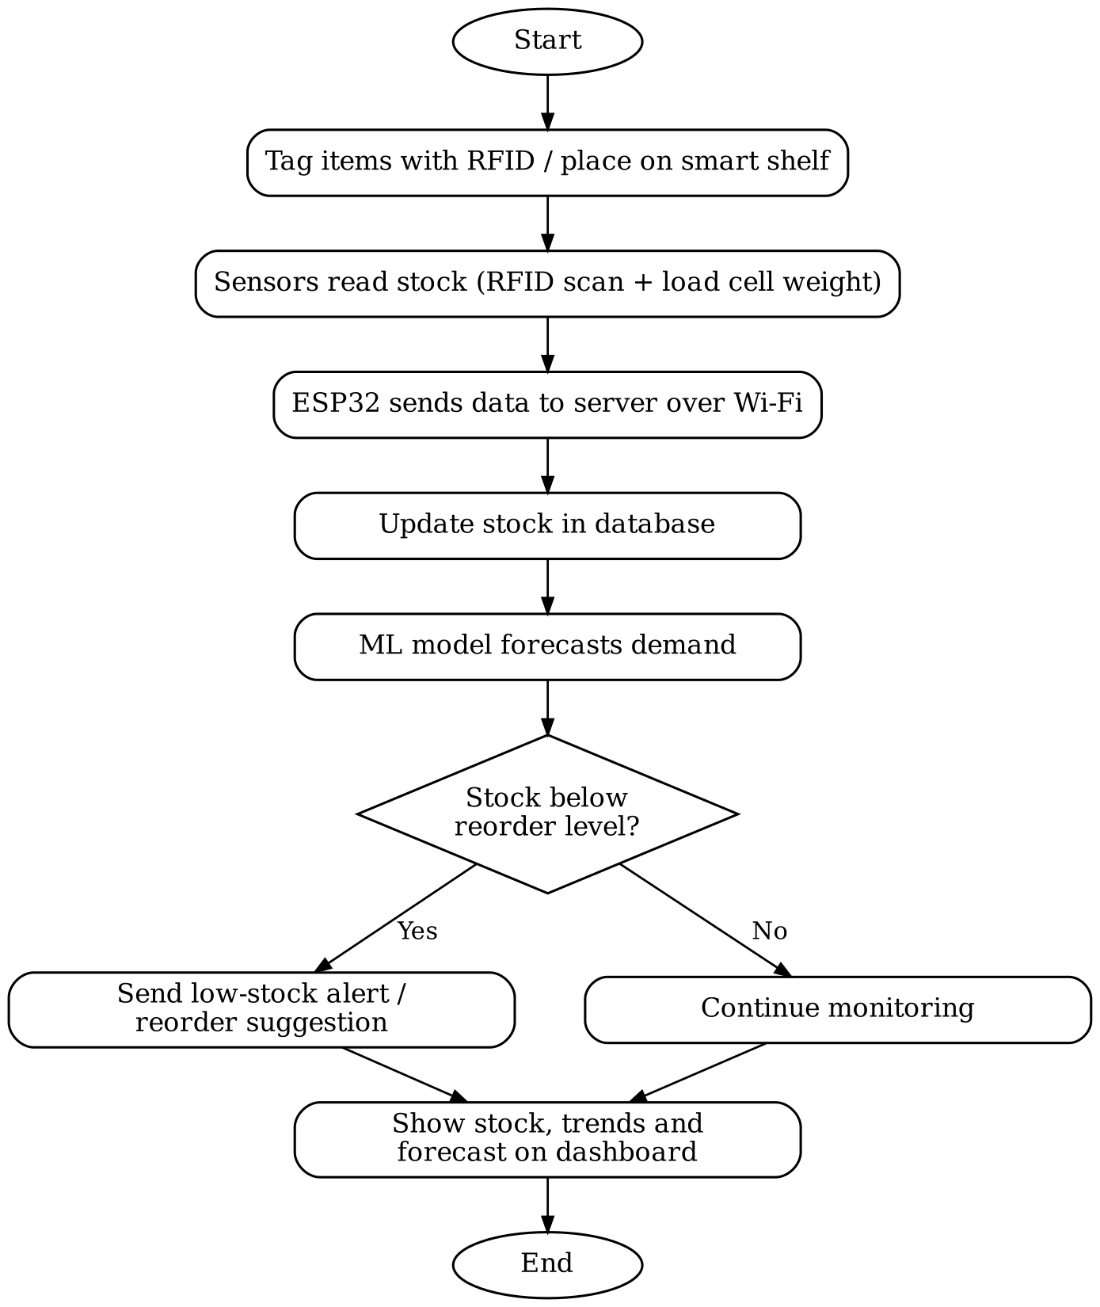
Fig 3.1: Working of Smart Inventory Management System [7, p.1][8, p.a176][9,p.3]
The working of the Smart Inventory Management System consists of the following steps:
1. Start: The system is powered on and the ESP32 connects to the Wi-Fi network and the server.
2. Tag items / place on smart shelf: Each item or box is given an RFID tag, and bulk items are kept on shelves fitted with load cells.
3. Sensors read stock: When an item is added or issued, the RFID reader scans its tag and the load cell measures the change in shelf weight.
4. Send data to server: The ESP32 sends the item ID, quantity, time and storage conditions to the backend server over Wi-Fi.
5. Update database: The server updates the current stock and saves the transaction in the database for history and analysis.
6. Forecast demand: The ML model uses past consumption data to predict the demand for the coming days or weeks.
7. Check reorder level: The system compares the current stock with the reorder level calculated from the forecast.
8. Send alert or continue monitoring: If stock is below the reorder level, a low-stock alert and reorder suggestion is sent; otherwise monitoring continues.
9. Show on dashboard: Current stock, item history, consumption trends and forecasts are displayed on the web dashboard.
10. End: The cycle repeats for every stock movement.
3.6 System Architecture and Main Components
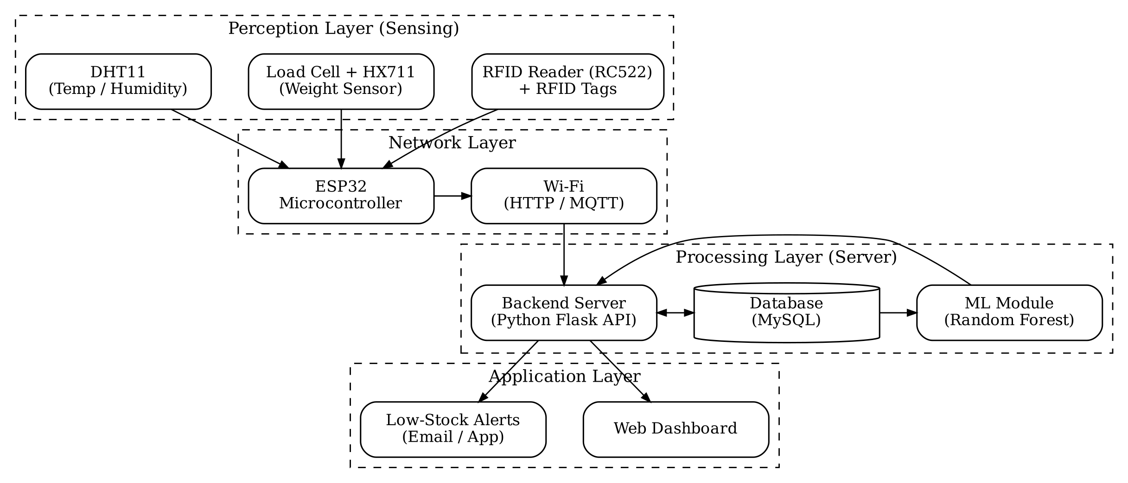
Fig 3.2: Architecture of Smart Inventory Management System[5,p.696][9,p.2][11,p.1731]
Bousselmi et al., “IoT Application for Smart Inventory Management System Based on RFID”
The proposed system follows a four-layer IoT architecture:
- Perception Layer: RFID reader (RC522) with tags, load cell with HX711 amplifier and DHT11 sensor capture item identity, quantity and storage conditions.
- Network Layer: The ESP32 microcontroller reads all sensors and transmits the data over Wi-Fi using HTTP or MQTT.
- Processing Layer: A Python Flask backend receives the data, stores it in a MySQL database and runs the Random Forest model for demand forecasting.
- Application Layer: A web dashboard shows live stock and forecasts, and the alert module sends low-stock notifications by email or app.
3.7 Example of Smart Inventory Management in a College Department
Consider a college Computer Department lab that stores 50 Arduino boards. Each board box has an RFID tag. When a student issues a board, the RFID reader at the store records the item, the student and the time, and the stock becomes 49 on the dashboard immediately. Based on the issue history of previous semesters, the ML model predicts that about 40 boards will be needed during the practical session in the coming month. If the available stock falls below the reorder level, the lab in-charge receives an alert to arrange or purchase more boards before practicals are affected.
3.8 Applications at Different Scales
- Large industry and supply chains: Demand forecasting and logistics optimization across warehouses and transport (Yu, 2025).
- Manufacturing / learning factories: Smart bins with weight mats supplying parts to assembly stations (Chukomin et al., 2023).
- Retail and food industry: Smart shelves, RFID and forecasting to avoid stock-outs and food wastage (Bhatt and Nahar, 2025; Singh et al.).
- Small warehouses and shops: Low-cost ESP32 and QR/RFID systems with cloud dashboards (Kamali et al., 2025; Bousselmi et al.).
- College departments and laboratories: RFID-based issue and return tracking of lab equipment (Bandara et al., 2024).

CHAPTER 4

ADVANTAGES AND DISADVANTAGES
4.1 Advantages:
1. Real-time and accurate stock information without manual counting.
2. Reduction in human errors, paperwork and time spent on stock-taking.
3. Accurate demand forecasting prevents both stock-outs and over-stocking.
4. Automatic low-stock alerts and reorder suggestions.
5. Complete history of every item, improving accountability and reducing loss or theft.
6. Monitoring of storage conditions protects perishable and sensitive items.
7. Low-cost hardware such as ESP32 and RC522 makes the system affordable for small organizations and departments.
4.2 Disadvantages:
1. Initial cost of sensors, tags, setup and training of staff.
2. Low-cost RFID readers have a short reading range and may miss tags.
3. ML forecasts depend on the quality and quantity of past data; new items have little history.
4. Dependence on internet connectivity and power supply.
5. Data security and privacy risks when data is stored on the cloud.
6. Integration with existing software and maintenance of hardware need technical skills.
[8][9][7][2]

CHAPTER 5

CONCLUSION
The study of research papers on Smart Inventory Management shows that IoT and AI/ML together can change inventory management from a manual, reactive process into an automatic, data-driven and proactive one. IoT technologies such as RFID, weight sensors, QR codes and environmental sensors provide accurate real-time stock information, while ML models, especially Random Forest and ensemble models, provide reliable demand forecasts that guide reordering.
The reviewed papers also show that this approach is not limited to large industries. The same concept has been applied in supply chains, factories, retail stores, small warehouses and even a single laboratory, with low-cost hardware like the ESP32 and RC522. At the same time, gaps remain: many small-scale systems only track stock without forecasting, while many forecasting systems are not connected to real sensors. Combining both in a low-cost system for a college department or small store is therefore a meaningful and practical project, which is proposed in the next chapter. [9,p.6][10,p.6][11, p.1729]

CHAPTER 6

PROJECT INITIATION
6.1) Description of Problem Statement:
In college departments, laboratories and small stores, inventory of equipment, components and consumables is still maintained in paper registers or spreadsheets. Stock is checked manually, items are issued and returned without proper tracking, and purchase decisions are made by guesswork. This results in shortage of items during practicals or sales, unnecessary purchase of excess stock, loss or misplacement of equipment and no clear record of who used what.
Existing commercial solutions are expensive and designed for large warehouses, while most low-cost systems described in the literature only track stock and do not predict future demand. Therefore, there is a need for a low-cost Smart Inventory Management System that automatically tracks stock using IoT sensors and uses Machine Learning to forecast demand and alert the user before stock runs out.[8, p.a174][9, p.6][10, p.6]
6.2) Scope and Objectives:
Scope of the Project: The project aims to design and develop a prototype Smart Inventory Management System for a college department, laboratory or small store. The system will use an ESP32 microcontroller with RFID and load-cell sensors to record items and quantities, store data in a database through a backend server, display live stock on a web dashboard, and use a Machine Learning model to forecast demand and generate low-stock alerts. The prototype will be tested on a small set of items and can later be extended to multiple storage locations.
Objectives of the Project:
1. To study existing IoT and AI/ML based inventory management systems through research papers.
2. To track the issue and return of items automatically using RFID.
3. To measure the quantity of bulk items on shelves using load-cell weight sensors.
4. To store all stock movements in a central database with complete history.
5. To forecast future demand using a Machine Learning model such as Random Forest.
6. To send automatic low-stock alerts and reorder suggestions.
7. To provide a simple web dashboard for viewing stock, history and forecasts.
6.3) Stakeholders:
The stakeholders of the Smart Inventory Management System are the people and groups who will use the system, build and maintain it, or be affected by it.
Table No. 6.1: Stakeholders
Sr. No. | Stakeholder | Role / Interest
1 | Lab In-charge / Store Keeper | Main user who manages stock, issues items and receives low-stock alerts.
2 | Students and Staff | Borrow equipment and components; their issue and return records are maintained.
3 | Head of Department / Management | Uses reports and forecasts for purchase planning and budgeting.
4 | Small Shop / Business Owners | Can use the same system to manage stock and avoid stock-outs.
5 | Suppliers / Vendors | Receive timely orders based on forecasted demand.
6 | Developers (Project Team) | Design, build, test and maintain the hardware and software.
7 | Project Guide and Evaluators | Faculty members who guide and evaluate the project.

6.4) Platform / Equipment / Resources Identification:
1. Platform:
The system will be developed on Windows or Linux. The ESP32 firmware will be written in C/C++ using the Arduino IDE. The backend and Machine Learning module will be developed in Python using Flask and scikit-learn, with MySQL as the database. The dashboard will be a web application accessible from any browser on a computer or mobile phone. Visual Studio Code will be used as the main code editor.
2. Equipment:
Table No. 6.2: Equipment
Sr. No. | Equipment | Purpose
1 | ESP32 Development Board | Main microcontroller with built-in Wi-Fi to read sensors and send data.
2 | RFID Reader (RC522) and RFID Tags/Cards | Identify items during issue and return.
3 | Load Cell with HX711 Amplifier | Measure weight on a shelf to calculate quantity of items.
4 | DHT11 Sensor (optional) | Monitor temperature and humidity of storage area.
5 | Buzzer / LED and 16x2 LCD (optional) | Local indication of scans and low stock.
6 | Computer or Laptop | Development, running the server and the dashboard (minimum 8 GB RAM recommended).
7 | Wi-Fi Router / Internet Connection | Communication between ESP32, server and users.

3. Resources:
Table No. 6.3: Resources
Resources | Name | Purpose
Operating System | Windows 11 / Linux | Host development tools and run the server.
Microcontroller IDE | Arduino IDE | Write and upload ESP32 firmware.
Programming Languages | C/C++, Python 3.11, JavaScript | Firmware, backend/ML and dashboard.
Backend Framework | Flask (Python) | REST API to receive sensor data and serve the dashboard.
Database | MySQL | Store items, stock levels and transaction history.
ML Library | scikit-learn, pandas, NumPy | Train Random Forest model for demand forecasting.
Frontend | HTML, CSS, JavaScript, Chart.js | Web dashboard with stock tables and charts.
Code Editor | Visual Studio Code | Coding, debugging and testing.
Communication | Wi-Fi with HTTP / MQTT | Send data from ESP32 to the server.

CHAPTER 7

SEMINAR PRESENTATION
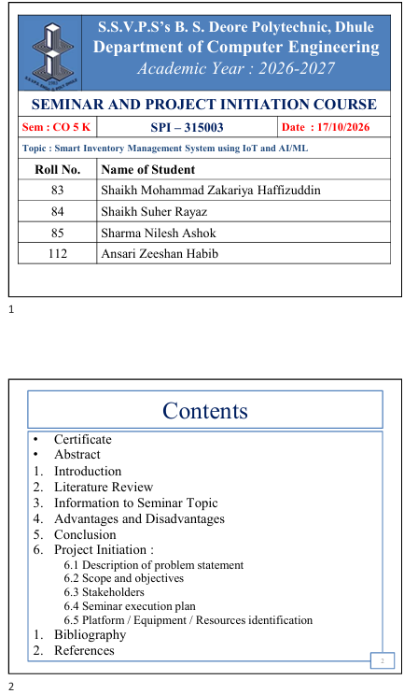

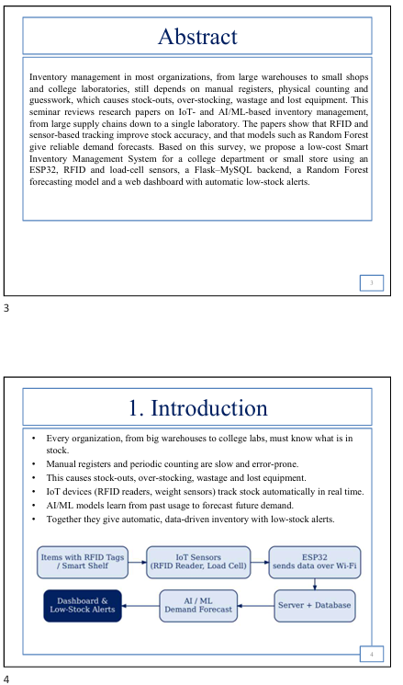

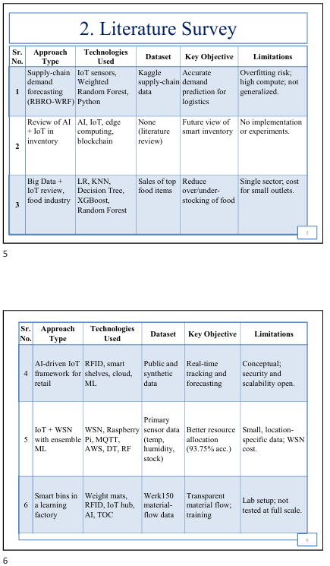

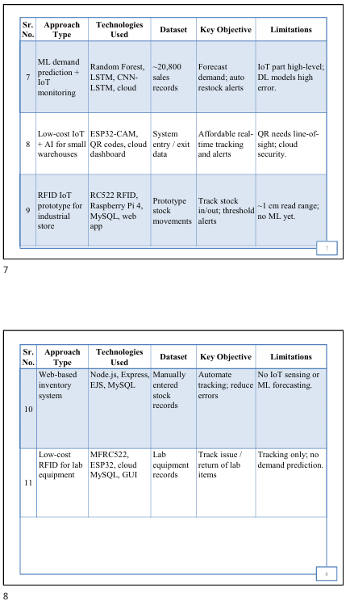

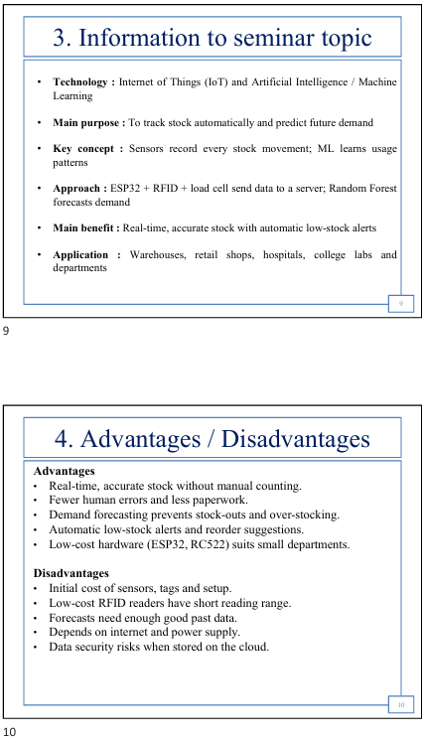

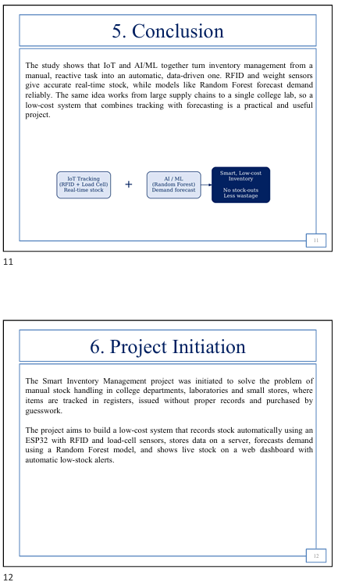

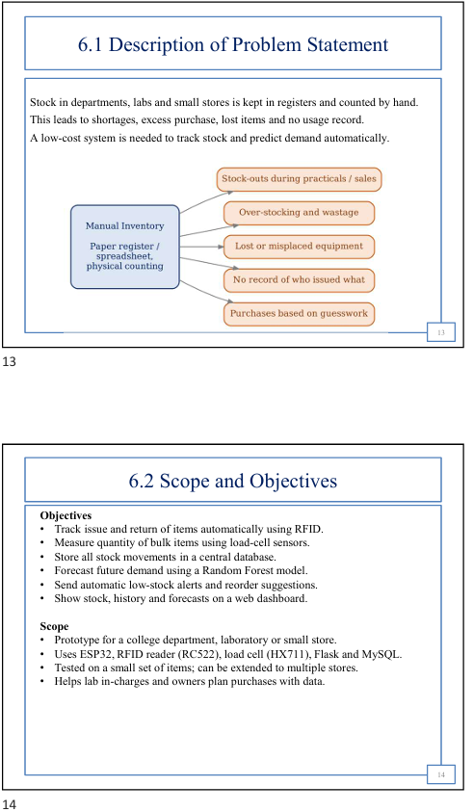

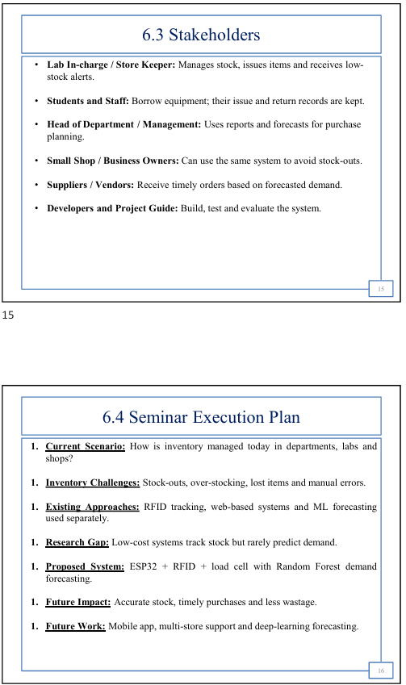

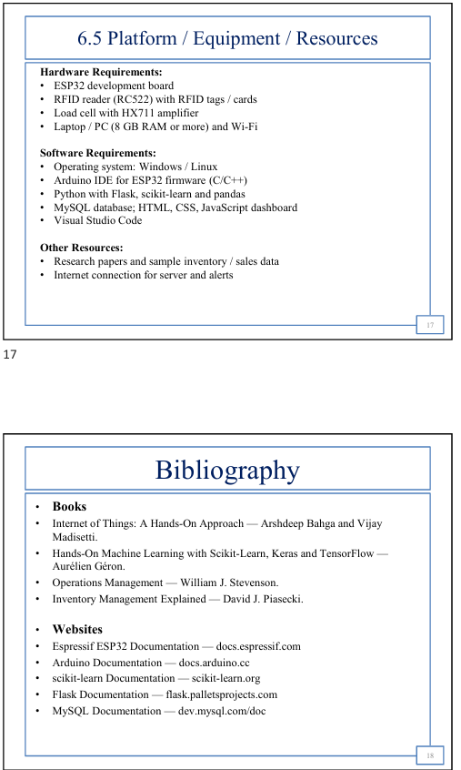

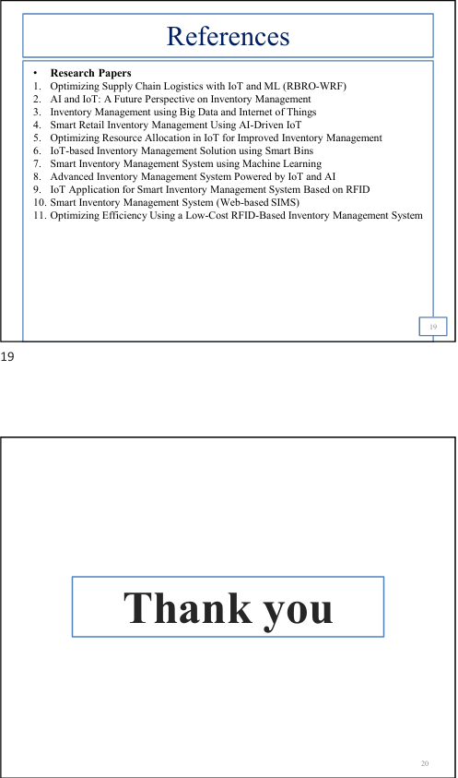

BIBLIOGRAPHY
1. Yu, Y. (2025). “Optimizing Supply Chain Logistics with IoT and Machine Learning: From Data Collection to Decision Making Based on Refined Battle Royale Optimizer Weighted Random Forest.” Informatica, 49, pp. 39–50. https://doi.org/10.31449/inf.v49i18.7301
2. Singh, N., and Adhikari, D. (2023). “AI and IoT: A Future Perspective on Inventory Management.” International Journal for Research in Applied Science & Engineering Technology (IJRASET), 11(XI). https://doi.org/10.22214/ijraset.2023.57200
3. Singh, S., Ranjan, H., Khatri, V., Agarwal, A. K., Hussain, S., and Garg, P. “Inventory Management using Big Data and Internet of Things.” Indira Gandhi Delhi Technical University for Women, New Delhi.
4. Bhatt, A. P., and Nahar, P. (2025). “Smart Retail Inventory Management Using AI-Driven IoT.” Journal of Supply Chain Management Systems, 14(1), pp. 30–36. https://doi.org/10.21863/jscms/2025.14.1.003
5. Kotru, A., and Batra, I. (2024). “Optimizing Resource Allocation in IoT for Improved Inventory Management.” International Journal of Computing and Digital Systems, 16(1). http://dx.doi.org/10.12785/ijcds/160151
6. Chukomin, A., Hummel, V., Hvozdov, S., Izmailova, T., and Schuhmacher, J. (2023). “Development of an IoT-based Inventory Management Solution and Training Module using Smart Bins.” 13th Conference on Learning Factories (CLF 2023). Available at SSRN: https://ssrn.com/abstract=4470627
7. Saxena, M., Verma, B., Sharma, N., and Tiwari, A. (2025). “Smart Inventory Management System using Machine Learning.” GLIMPSE – Journal of Computer Science, 4(2).
8. Kamali, R., Ganesan, R. T., Dhanush Raja, M., Jeisurya, S., and Kamala Kannan, N. G. (2025). “An Advanced Inventory Management System Powered by IoT and AI for Real-Time Tracking and Optimization.” International Journal for Research Trends and Innovation (IJRTI), 10(4), pp. a173–a179.
9. Bousselmi, S., Gannouni, M., and Ouni, K. “IoT Application for Smart Inventory Management System Based on RFID.” IEEE conference paper, National Engineering School of Carthage, University of Carthage, Tunisia.
10. Reddy, B. N., Reddy, K. Y., Manda, V. S., Varaprasad, R., and Reddy, P. V. (2025). “Smart Inventory Management System.” International Journal of Innovative Research in Science, Engineering and Technology (IJIRSET), 14(4). https://doi.org/10.15680/IJIRSET.2025.1404462
11. Bandara, I., Simpson, O., and Sun, Y. (2024). “Optimizing Efficiency Using a Low-Cost RFID-Based Inventory Management System.” 20th IEEE International Wireless Communications and Mobile Computing Conference (IWCMC 2024), pp. 1729–1733. https://doi.org/10.1109/IWCMC61514.2024.10592581

REFERENCES
[1] Espressif Systems, “ESP32 Technical Documentation.” [Online]. Available: https://docs.espressif.com/projects/esp-idf/en/latest/esp32/
[2] NXP Semiconductors, “MFRC522 Standard Performance MIFARE and NTAG Frontend – Data Sheet.” [Online]. Available: https://www.nxp.com/docs/en/data-sheet/MFRC522.pdf
[3] Arduino, “Arduino Documentation.” [Online]. Available: https://docs.arduino.cc/
[4] Pallets Projects, “Flask Documentation.” [Online]. Available: https://flask.palletsprojects.com/
[5] Oracle, “MySQL Documentation.” [Online]. Available: https://dev.mysql.com/doc/
[6] scikit-learn developers, “RandomForestRegressor – scikit-learn Documentation.” [Online]. Available: https://scikit-learn.org/stable/modules/generated/sklearn.ensemble.RandomForestRegressor.html
[7] Python Software Foundation, “Python 3 Documentation.” [Online]. Available: https://docs.python.org/3/
[8] K. Ashton, “That ‘Internet of Things’ Thing,” RFID Journal, 22 June 2009.
[9] University of Cambridge, Institute for Manufacturing, “The Origin of the Internet of Things.” [Online]. Available: https://www.ifm.eng.cam.ac.uk/news/the-origin-of-the-internet-of-things
[10] Engineering and Technology History Wiki (ETHW), “Kevin Ashton.” [Online]. Available: https://ethw.org/Kevin_Ashton
Research Papers Referred – Content and Page Numbers
Table No. 8.1: Research papers, pages referred and content used
Sr. No. | Research Paper | Pages Referred | Content / Diagram Used (Chapter)
1 | Yu (2025), “Optimizing Supply Chain Logistics with IoT and Machine Learning” | pp. 39, 42–48 | Supply-chain demand forecasting with Weighted Random Forest; MAPE 3.41% (Ch. 2, 3.4, 3.8, 5)
2 | Singh and Adhikari (2023), “AI and IoT: A Future Perspective on Inventory Management” | pp. 2, 4–6 | Benefits (real-time tracking, predictive analytics, automated replenishment) and challenges (Ch. 2, 4)
3 | Singh et al., “Inventory Management using Big Data and Internet of Things” | pp. 1–2, 4–5, 7 | Comparison of LR, KNN, DT, XGBoost, Random Forest; food-industry problems (Ch. 1, 2, 3.2, 3.4)
4 | Bhatt and Nahar (2025), “Smart Retail Inventory Management Using AI-Driven IoT” | pp. 30–35 | Limits of manual systems; smart shelves, RFID, cloud framework (Ch. 1, 2, 3.1, 3.2)
5 | Kotru and Batra (2024), “Optimizing Resource Allocation in IoT for Improved Inventory Management” | pp. 685, 694–696, 700–701 | IoT + WSN setup, MQTT/cloud layer for Fig 3.2; 93.75% accuracy (Ch. 1, 2, 3.3, 3.4, 5)
6 | Chukomin et al. (2023), “Development of an IoT-based Inventory Management Solution and Training Module using Smart Bins” | pp. 1, 4 | Smart bins with weight mats (Ch. 2, 3.3, 3.8)
7 | Saxena et al. (2025), “Smart Inventory Management System using Machine Learning” | pp. 1, 3 | Random Forest forecasting, restock alerts for Fig 3.1; 30% accuracy gain (Ch. 1, 2, 3.4, 5)
8 | Kamali et al. (2025), “An Advanced Inventory Management System Powered by IoT and AI for Real-Time Tracking and Optimization” | pp. a173–a174, a176, a178 | ESP32-CAM/QR workflow used for Fig 3.1; challenges (Ch. 2, 3.1, 3.3, 4)
9 | Bousselmi et al., “IoT Application for Smart Inventory Management System Based on RFID” | pp. 1–3, 6 | RFID RC522 perception layer for Fig 3.2; threshold alerts for Fig 3.1 (Ch. 1, 2, 3.3, 4)
10 | Reddy et al. (2025), “Smart Inventory Management System” | pp. 2–6 | Web-based system design and future work used for research gap (Ch. 1, 2, 6.1)
11 | Bandara et al. (2024), “Optimizing Efficiency Using a Low-Cost RFID-Based Inventory Management System” | pp. 1729–1733 | ESP32 + MFRC522 lab tracking for Fig 3.2 and example 3.7 (Ch. 1, 2, 3.3, 3.7)

SEMINAR AND PROJECT INITIATION Assessment / Evaluation
Sr. No | Enrollment Number | Seat Number | Name of Student
1 | 24610960269 | 388570 | Shaikh Mohammad Zakariya Haffizuddin
2 | 24610960270 | 388571 | Shaikh Suher Rayaz
3 | 24610960271 | 388572 | Sharma Nilesh Ashok
4 | 24610960300 | 388599 | Ansari Zeeshan Habib

Formative Assessment
Sr. No. | Criteria | Weightage | Exam Seat Number
Sr. No. | Criteria | Weightage | 388570 | 388571 | 388572 | 388599
1 | Selection Topic / Theme of seminar | 5
2 | Literature review and data presentation | 5
3 | Quality of Preparation and innovativeness | 5
4 | Q-A handling | 5
5 | Time Management | 5
6 | Seminar Presentation report | 10
7 | Selection of Theme of Problem Statement and its innovativeness | 5
8 | Stages of development of Action plan | 5
9 | Prototyping | 5
 | Total | 50
 | Scaled to 25

Sign :
Name : ......................................................
(Course Expert/s)

